CHAR_LENGTH()
- This function is used to determine the amount of characters in a string. This function could be useful for validating character length for text input like password length requirements.
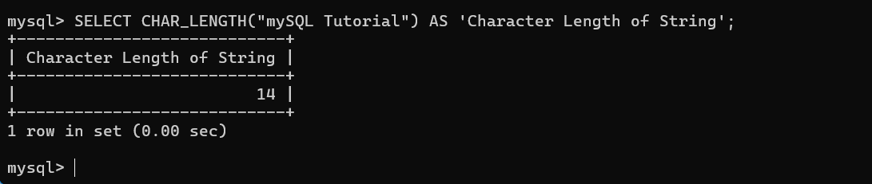
LOWER()
- This function converts text to all lowercase characters. It’s useful when certain fields require lowercase formatting for consistent comparisons and normalization.
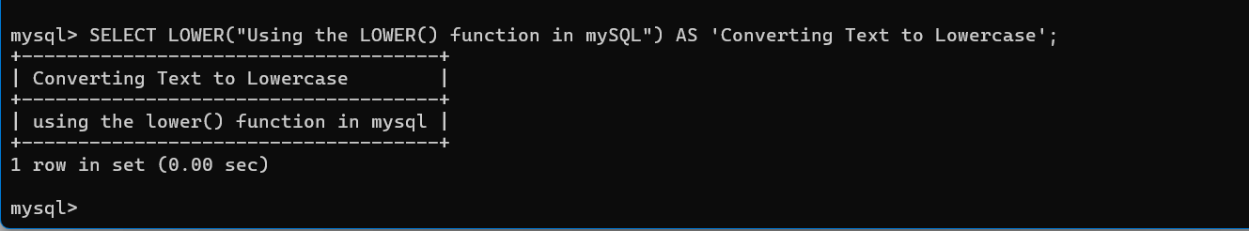
REPEAT()
- This function repeats a string for a specified number of times. It’s useful for generating padding for formatting purposes.
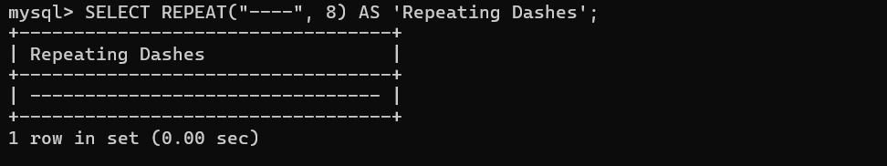

References
w3resource. (2023a, July 17). MySQL CHAR_LENGTH() function. W3resource. https://www.w3resource.com/mysql/string-functions/mysql-char_length-function.php
w3resource. (2023b, July 17). MySQL LOWER() function. W3resource. https://www.w3resource.com/mysql/string-functions/mysql-lower-function.php
w3resource. (2023c, July 24). MySQL repeat() function. W3resource. https://www.w3resource.com/mysql/string-functions/mysql-repeat-function.php

